**Attention Seniors**

**FINAL TRANSCRIPT REQUEST**

All transcript requests will go through Scribbles: [**https://lewisvilletx.scriborder.com**](https://secure-web.cisco.com/1dOOxDGs5FIJm1MLa9WU0CJW5SYmo1lpfrrgZ_vlxhLzhY7XKR_UZy7QD-9SsGz-HgIpok5JMXBtRFSaJWnUl9z6M8iV7zugoToD7aJbuhZ7BWjg5HB800SPuWJQYP2pPhXUjelI4rb9onjjW0cH8CrQct86FAULAVko9TAuQnuvY3VOwoTdBmsK6QPwhHtOa8s3vPYkhRlOlsiTD1r9vw87YAqQXkYBmaLbDUA_tCkNUPJQSqGvPxBPDOexgib9l4HpmmDMR2Q30m4rf0ryqzebpNHFZC18fr_w5pdktA0A94ZlehTCobM1zSbdkr48KwNRg51MrnPePiF5aSM62fT16N0IgZhCo_xp52DTQd6c32r5AsBf5QobAqHw5LiJeVKrtwWeZy1IzOqqGRh8GLJz9w_fkMweHWCKdA5UN_1S8tqau9dZqUVAGfdWzYjBc/https%3A%2F%2Flewisvilletx.scriborder.com%2F)

The link can also be accessed from the FMHS counselor’s page on the **FMHS website:**

[**www.lisd.net/fmhs**](http://www.lisd.net/fmhs) **🡪 Counseling 🡪Transcript Requests 🡪 TRANSCRIPT REQUESTS**

Select Current Student and create an account, if you have not already done so. Enter all of your information and then select all of the highlighted information below:

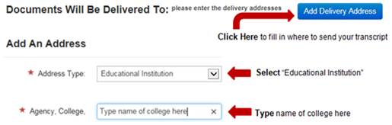

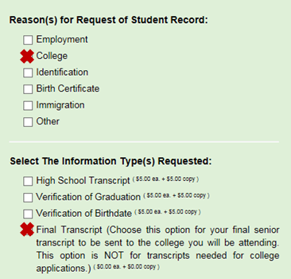

Final Transcripts will be available and sent approximately two weeks or more after the completion of the school year and will include total credits earned and graduation date. Only one final transcript will be sent to the college you are attending.

If you have questions or special transcript requests, please contact [FMHS-Records@lisd.net](mailto:FMHS-Records@lisd.net). Please note that the Registrars are off for Summer Break from June 22 - July 10, 2023 and no transcripts will be sent during this time.