Peters Colony Pep Squad

To generate school spirit and respect for tradition and sportsmanship in our student body

Teach the six pillars of good character and ethical values: Trustworthiness, Respect, Responsibility, Fairness, Caring and Citizenship.

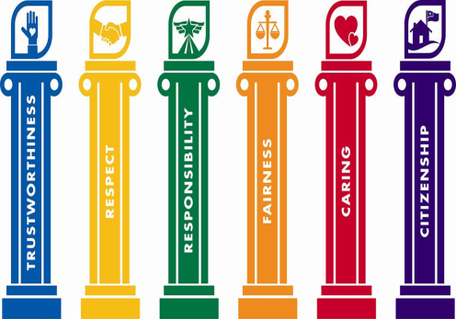

Ms. Cynthia Valverde Ms. Gracie Lopez

[valverdec@lisd.net](mailto:valverdec@lisd.net) [lopezg@lisd.net](mailto:lopezg@lisd.net)